**SHOCK TUBE SIMULATION**

**REPORT (MIN-345)  
Compressible flow**

Deepanker Singh-21117039

Gaurav Singh-21117045

Gaurav Singh-21117046



**DEPARTMENT OF MECHANICAL AND INDUSTRIAL ENGINEERING**

**INDIAN INSTITUTE OF TECHNOLOGY, ROORKEE**

**ROORKEE- 247667 (INDIA)**

*Under the guidance of*

Prof. Ankit Bansal

**ACKNOWLEDGEMENT**

We would like to express our sincere gratitude to Prof. Ankit Bansal for his invaluable guidance, unwavering support, and the opportunity to undertake this project on simulating the time period of a shock tube in Ansys Fluent. His expertise and mentorship have been instrumental in shaping our understanding and approach throughout this endeavour.

We extend our deepest appreciation to all the team members for their dedication, hard work, and collaboration, without which this project would not have been possible. Each member's unique contributions have significantly enriched the project and its outcomes.

TABLE OF CONTENTS Page No.

|  |  |  |
| --- | --- | --- |
| 1) | Abstract | 3 |
| 2) | Introduction | 3 |
| 3) | Problem Statement | 4 |
| 4) | Governing Equation | 4 |
| 5) | Methodology | 5 |
| 5) | Results | 11 |
| 6) | Conclusion | 12 |
| 7) | References | 13 |

ABSTRACT

This study investigates the interaction between a contact wave and a reflected shock within a shock tube setup comprising a driver section filled with N2 gas at high pressure and a driven section containing air at standard atmospheric pressure, both sections maintained at a uniform temperature of 300 K. The shock tube has dimensions of 6m for the driver section and 10 m for the driven section. The objective is to determine the time at which the contact wave and the reflected shock interact within the tube. To achieve this, a one-dimensional Computational Fluid Dynamics (CFD) simulation is developed. The simulation considers the governing equations of fluid dynamics, including conservation of mass, momentum, and energy, to model the flow behavior within the shock tube. By analyzing the pressure, temperature, and velocity profiles over time, the point of interaction between the contact wave and the reflected shock is identified. This research contributes to the understanding of shock wave dynamics and has implications for various applications in fluid mechanics, aerodynamics, and materials science.

INTRODUCTION

Shock tubes serve as invaluable tools in experimental fluid dynamics, enabling researchers to explore gas behaviour under extreme conditions of temperature and pressure. Operating within a broad range of temperature (500–10,000+ K) and pressure (0.01–1000+ atm), shock tubes facilitate near-instantaneous heating of test gases through the generation and propagation of shock waves.

At the heart of a shock tube lies its ability to rapidly heat test gases, making it a crucial apparatus for studying high-temperature and high-pressure phenomena. The setup typically consists of two main sections separated by a single-use diaphragm. The driver section, charged with a low-molecular weight gas like helium, initiates the experiment by increasing pressure until the diaphragm ruptures, inducing shock wave formation. This incident shock wave then propagates through the driven section, compressing and heating the test gas near-instantaneously.

The shock-heating process is remarkably swift, elevating the test gas from ambient temperature to temperatures exceeding 10,000 K and pressures surpassing 1000 atm within a mere 10 microseconds. As the incident shock reaches the end wall, it reflects back towards the driver end, further intensifying compression, heating, and ultimately leading to stagnation of the test gas.

In the realm of experimental testing, shock tubes offer unparalleled advantages, with test durations typically ranging from 3 to 10 milliseconds. This brief yet intense exposure to extreme conditions enables researchers to investigate various gas dynamic phenomena, including shock wave interactions, combustion processes, and chemical kinetics.

This report aims to delve into the intricacies of shock tube dynamics, exploring its fundamental principles, experimental methodologies, and applications in advancing our understanding of high-temperature, high-pressure gas dynamics. Through a comprehensive analysis, we seek to elucidate the pivotal role of shock tubes in scientific research and engineering endeavours, paving the way for future advancements in fluid dynamics and related fields.

PROBLEM STATEMENT

Given a shock tube with a driver section of 6 m long and driven section of 10 m long. The driver section contains N2 gas at 30 bar while the driven section contains air at standard atmospheric pressure. The temperature in both section is 300 K. Write a code or do a one-dimensional CFD simulation to determine the time when the contact wave and the reflected shock will interact.

GOVERNING EQUATION

1. Conservation of Mass: This equation states that the rate of change of mass within a control volume is equal to the net mass flow rate into or out of the control volume. Mathematically, it is expressed as:

2. Conservation of Momentum: This equation states that the rate of change of momentum within a control volume is equal to the sum of the forces acting on the control volume. Mathematically, it is expressed as:

3.Conservation of Energy: This equation states that the rate of change of energy within a control volume is equal to the sum of the energy fluxes into or out of the control volume, plus the work done on or by the gas. Mathematically, it is expressed as:

4. Equation of State: This equation relates the pressure, density, and temperature of the gas. For ideal gases, it is given by:

5. The Hugoniot equation, also known as the Rankine-Hugoniot equation, describes the conservation of mass, momentum, and energy across a shock wave. It provides a relationship between the properties of a fluid before and after passing through a shock wave.

The general form of the Rankine-Hugoniot equation for a one-dimensional, steady, and adiabatic shock wave is:

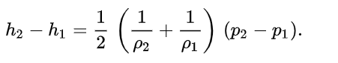

METHODOLOGY

This problem is tackled by using shock tube simulation in Ansys then doing iterations to calculate exact time when reflected shock will interact with contact wave.

**Geometry & Meshing:**

1. Create shock tube geometry  
    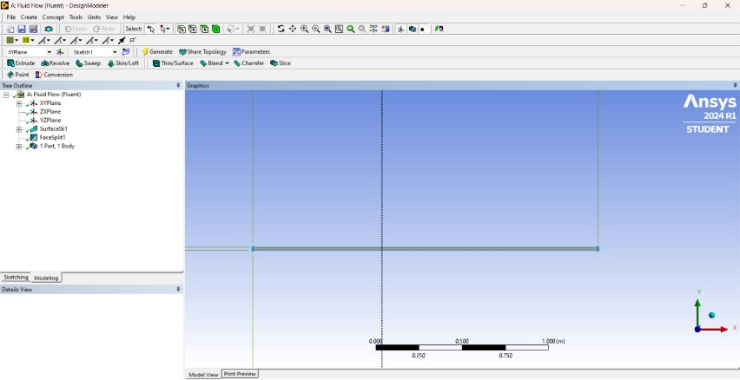

Total Length = 2m  
Driver section = 0.75m

Driven section = 1.25m

Diameter = 18mm

We have generated mesh by using number of divisions method and the shape we have chosen is quadrilateral. This is done in Meshing.

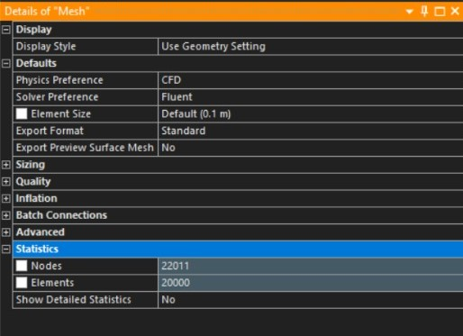

Details of Mesh

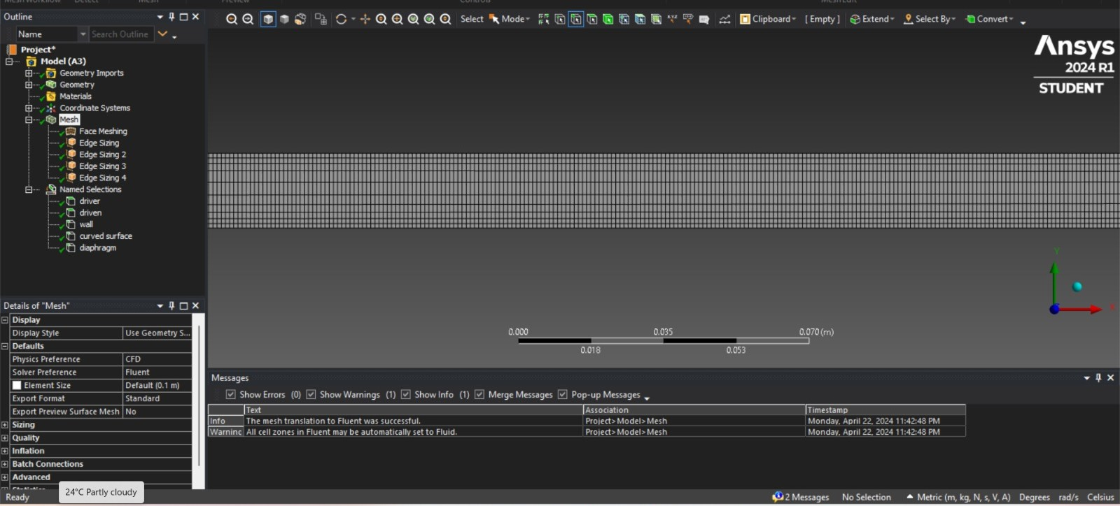

Quadrilateral Meshing done in Geometry

**Physics Setup**:

We initiated the fluid dynamics analysis by configuring the density-based solver within Ansys Fluent. This foundational step enabled us to accurately model the compressible flow phenomena within the shock tube. To delineate the distinct properties of the driver and driven sections, we designated nitrogen and air as the respective material fluids. Boundary conditions were meticulously assigned to the walls, enforcing stationary conditions and applying the no-slip constraint to simulate the interaction between the fluid and the solid boundaries. Additionally, we initialized the pressure and temperature according to the specifications outlined in the problem statement. This ensured that our simulation accurately represented the physical conditions of the shock tube experiment, laying a robust foundation for subsequent analyses.

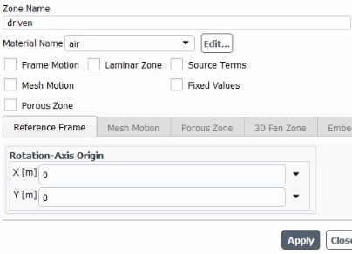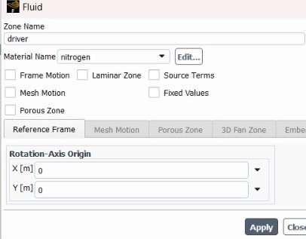

Materials assigned for the driver and driven section

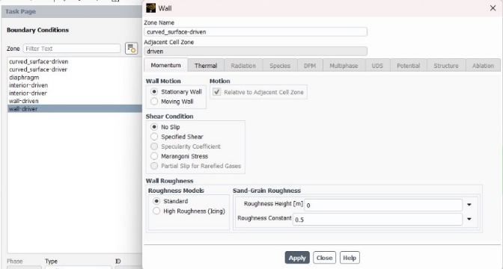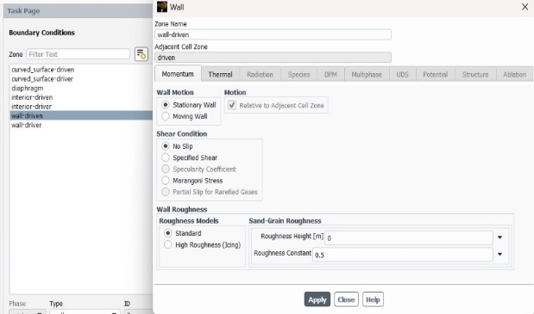

Boundary Conditions given to the wall

**Transient Simulation:**

Set up a transient simulation with appropriate time steps

According to the Courant-Friedrichs-Lewy (CFL) condition

​

Where:

* Δ*t* is the time step size,
* *C* is the CFL number (a dimensionless constant typically set between 0.1 and 1),
* Δ𝑥 is the smallest characteristic length scale,
* 𝑢 is the speed of sound.

The time step size we got at C=1 is 9.061e-6.  
To make C less than 1 we have taken Δ*t* = 7e-6.

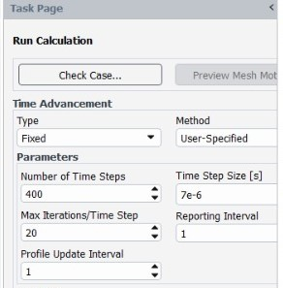

Initially, we set the number of time steps to 400, estimating the interaction time between the reflected shock and contact waves to be on the order of milliseconds. Subsequently, we iteratively increased the number of time steps by 70, 50, 30, 20, and then 10, refining the approximation of the interaction time. This stepwise adjustment allowed us to converge towards an approximate interaction time that better captured the transient behaviour of the system.

Top of Form

**Simulation and Analysis:**

During the simulation, we strategically visualized key variables such as pressure and temperature. These visualizations were essential for analysing the dynamics of the system and determining the interaction time of waves. By closely monitoring these variables, we were able to gain crucial insights into the behaviour of the fluid flow and accurately assess the timing of wave interactions.

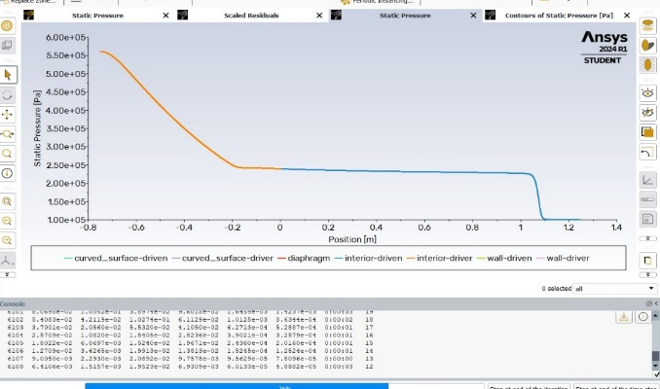 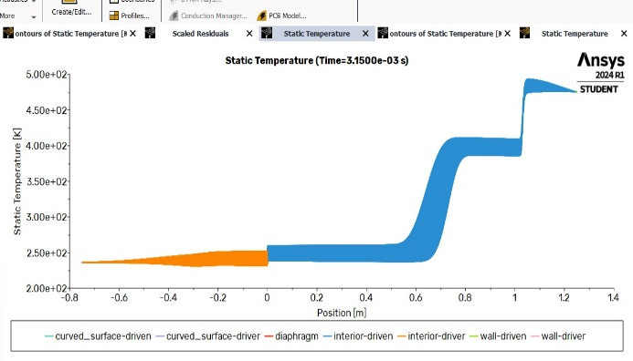

X-Y Plot of Static Temperature vs Distance x  
(before the interaction time of contact and   
reflected shock wave)

X-Y Plot of Static Pressure vs Distance x   
 (when shock wave was travelling)

**Analysis:**

Within the shock tube, we conducted simulations under varying numbers of time steps to pinpoint the interaction between the contact and reflected shock. Employing the prescribed conditions, including material properties and boundary settings, we meticulously modelled transient phenomena. Utilizing Ansys Fluent, we visualized temperature and pressure variations through X-Y graphs and contour plots. These graphical depictions enabled us to precisely identify the moment of wave interaction. By iteratively refining our simulations, we elucidated critical insights into the dynamic behaviour of the system. This iterative approach, coupled with thorough analysis of temporal dynamics, allowed us to accurately capture the intricate interplay between the waves, ultimately revealing the precise timing of their interaction.

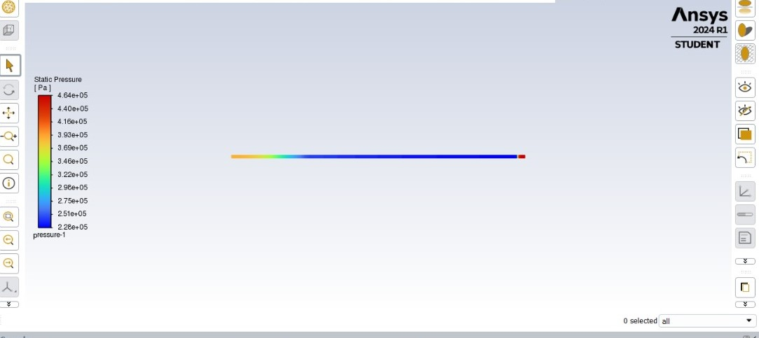

Shows the contour of pressure variation along the shock tube when Shock wave has been reflected back

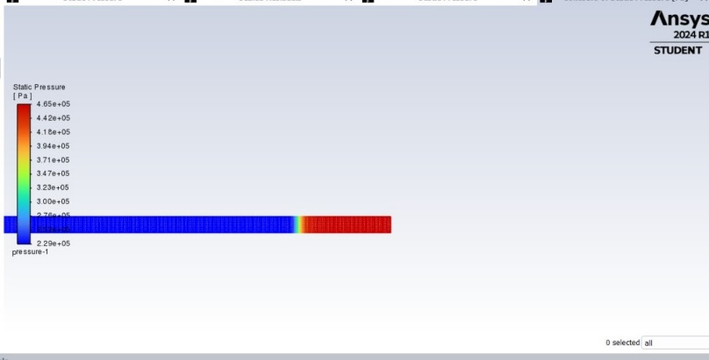

Shows the contour of pressure variation along the shock tube when expansion wave has been reflected back

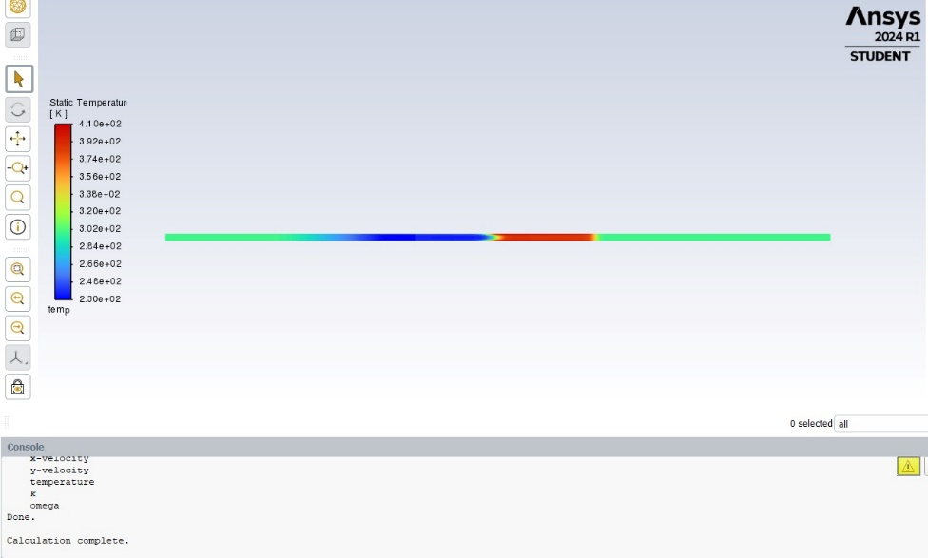

Shows the contour of temperature variation along the shock tube mid simulation.

RESULTS:

After rigorously iterating through adjustments in time steps to approximate the interaction time, we conclusively determined the approximate moment when the waves intersected. From this analysis, we derived the following pivotal data:

Top of Form

No of time Steps ~ 550  
Time Step Size = 7e-6  
Total interaction time taken = No of Time steps * Time Step size (seconds)  
 = 550 * 7e-6  
 = 3.8500e-03 seconds

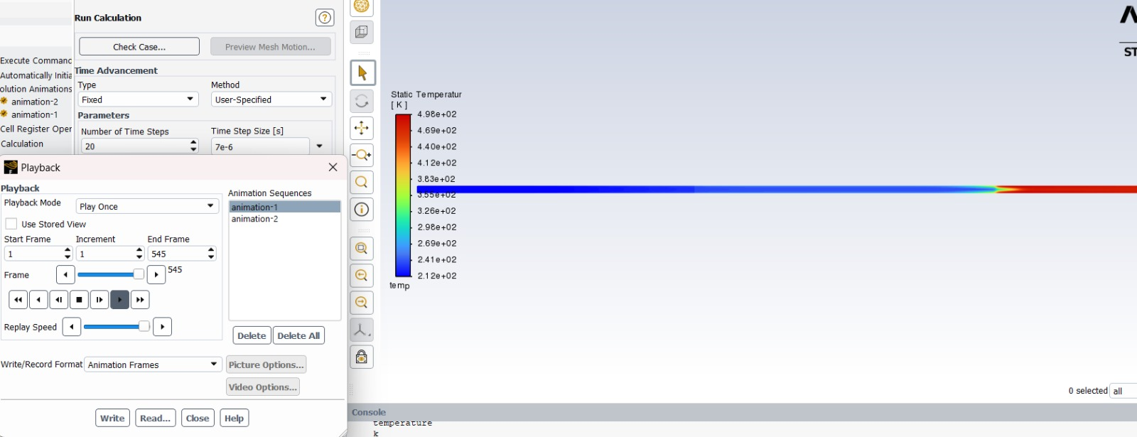

Contour Graph of Temperature variation along the shock tube when the reflected shock wave meets the contact wave

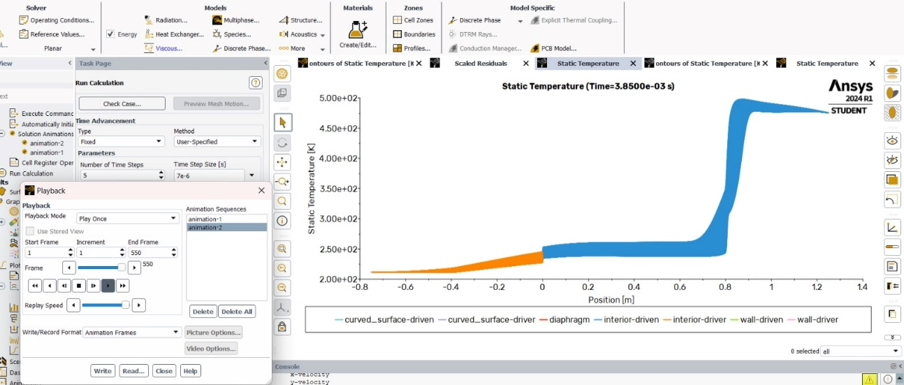

X-Y Plot of Static Temperature vs Distance x when the Contact wave interacts with the reflected shock wave

CONCLUSION:

In our shock tube simulation, we observed a sequence of events initiated by the rupture of the diaphragm, which generated a shock wave propagating through the driven section. Subsequently, a slower-moving contact wave followed the shock, while an expansion wave moved in the opposite direction. The contact wave eventually encountered the reflected shock in the driven section, fulfilling the objective of our problem statement to find the interaction time when the reflected shock meets the contact wave. By employing appropriate time steps and sizes derived from the CFL relation, we meticulously iterated to calculate this interaction time. After thorough simulation and analysis, we determined the final interaction time to be 3.8500e-03 seconds. This result stands as a culmination of our rigorous computational efforts to accurately capture the dynamics of shock wave interactions within the shock tube.

REFERENCES

<https://hanson.stanford.edu/our-approaches/shock-tubes>

<https://petersengroup.tamu.edu/research-2/gas-dynamics-chemical-kinetics/shock-tube-physics/>

<https://forum.ansys.com/forums/topic/simulation-of-a-jet-of-air-into-a-shock-tube/>

Top of Form